**Unit 5 : Uncertainty Management in Rule**

**Based Expert System**

***Prepared by Prof.Kore S.S***

**(Assistant Professor(CSE) DYPCET,Kolhapur)**

Uncertainty in expert systems

* Uncertainty can be defined as the lack of the exact knowledge that would enable us to reach a perfectly reliable conclusion
* e.g IF A is true THEN A is not false
* e.g B is false THEN B is not true
* The available information often contains inexact, incomplete or even unmeasurable data.

Sources of uncertain knowledge

* Weak implications.

Rule-based expert systems often suffer from weak implications and vague associations. Domain experts and knowledge engineers have the painful, and rather hopeless, task of establishing concrete correlations between IF ( condition) and THEN (action) parts of the rules.

* Imprecise language.

Our natural language is inherently ambiguous and imprecise. We describe facts with such terms as often and sometimes, frequently and hardly ever. As a result, it can be difficult to express knowledge in the precise IF-THEN form of production rules

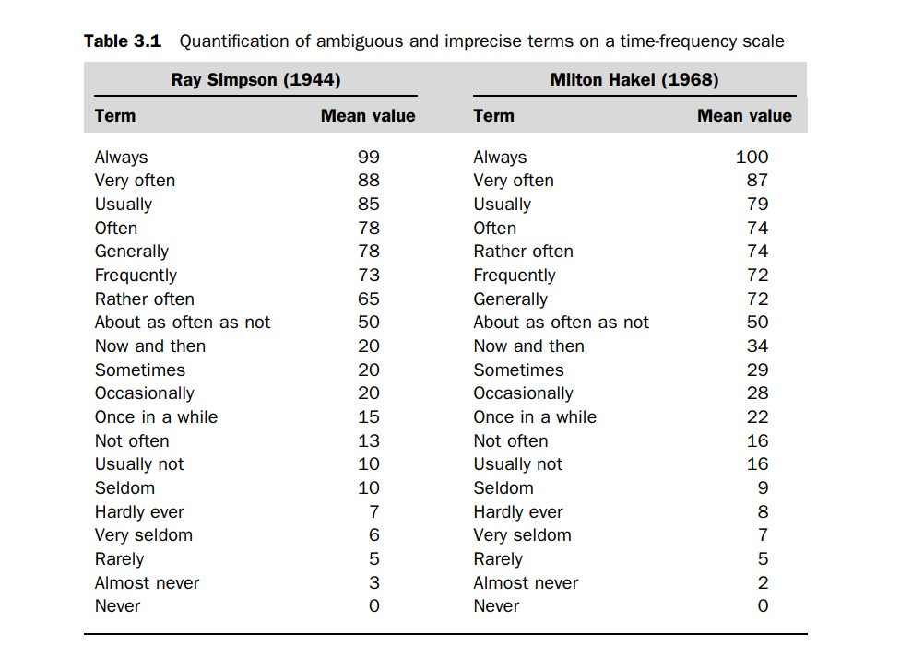

* Unknown data.

When the data is incomplete or missing, the only solution is to accept the value ‘unknown’ and proceed to an approximate reasoning with this value

* Combining the views of different experts.

Large expert systems usually combine the knowledge and expertise of a number of experts. Unfortunately, experts seldom reach exactly the same conclusions. Usually, experts have contradictory opinions and produce conflicting rules.

Basic probability theory

* Probability can be expressed mathematically as a numerical index with a range between zero (an absolute impossibility) to unity (an absolute certainty). Most events have a probability index strictly between 0 and 1, which means that each event has at least two possible outcomes: favorable outcome or success, and unfavorable outcome or failure.

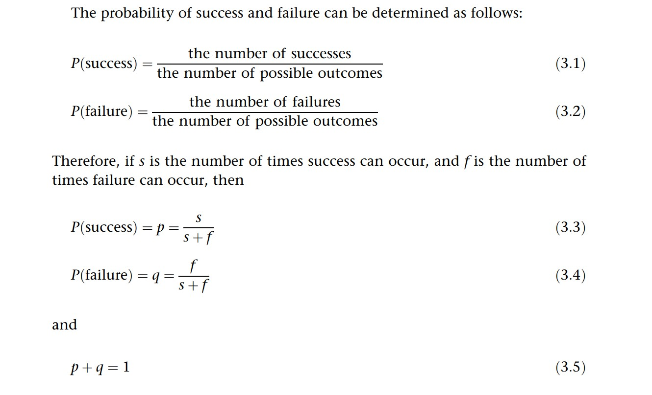

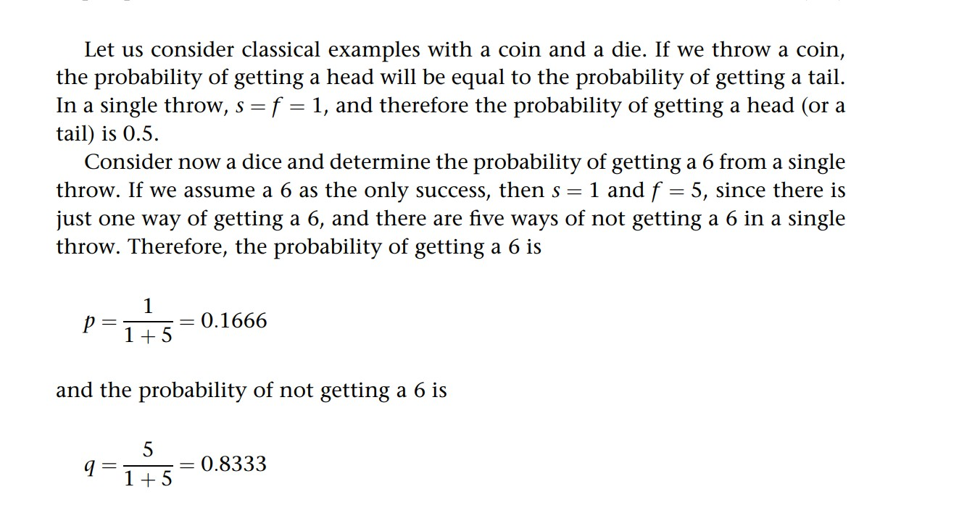

Conditional Probability

* Let A be an event in the world and B be another event.
* The probability that event A will occur if event B occurs is called the conditional probability. Conditional probability is denoted mathematically as P(A|B) in which the vertical bar represents GIVEN and the complete probability expression is interpreted as ‘Conditional probability of event A occurring given that event B has occurred’

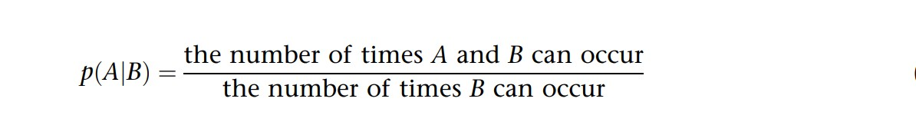

Joint probability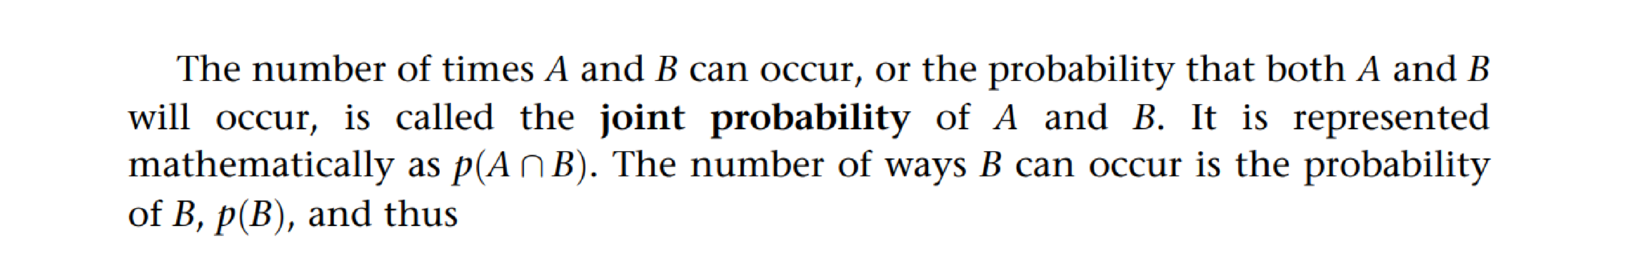

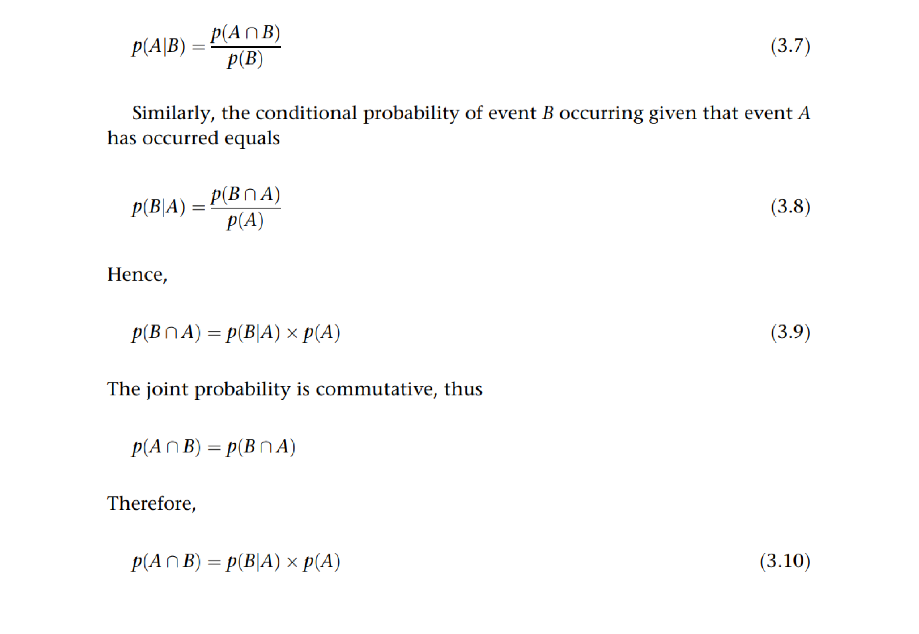

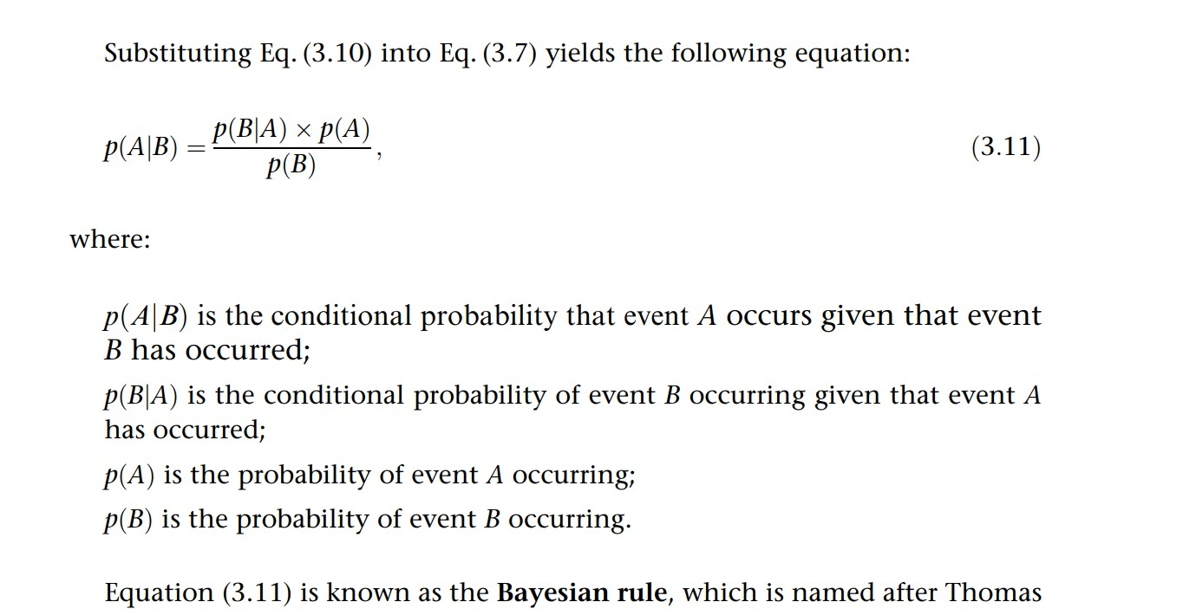

Bayesian reasoning

Suppose all rules in the knowledge base are represented in the following

IF E is true

THEN H is true {with probability p}

This rule implies that if event E occurs, then the probability that event H will occur is p.

* We simply use H and E instead of A and B. In expert systems, H usually represents a hypothesis and E denotes evidence to support this hypothesis

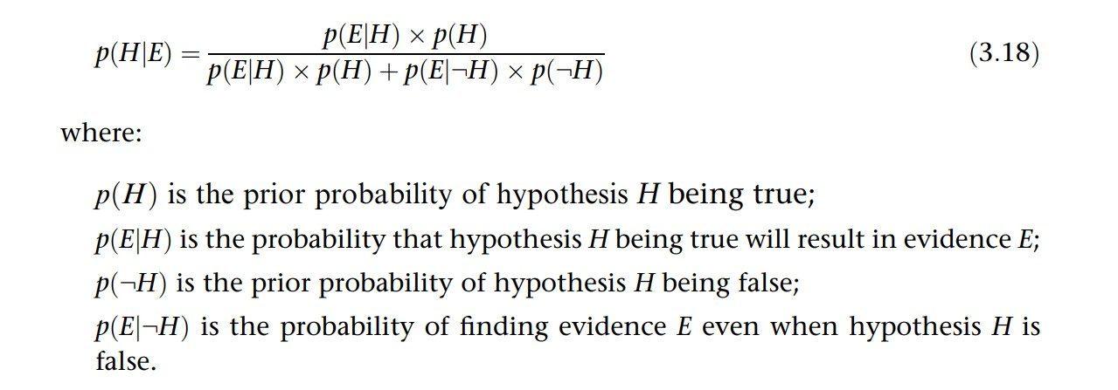

Probability p(H|E) is called the posterior probability of hypothesis H upon observing evidence E

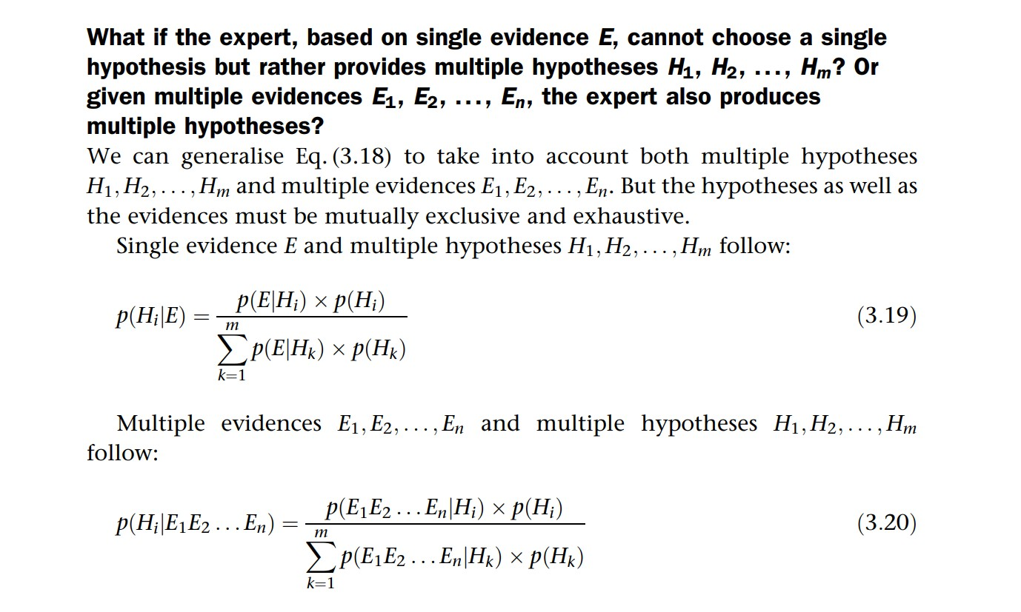

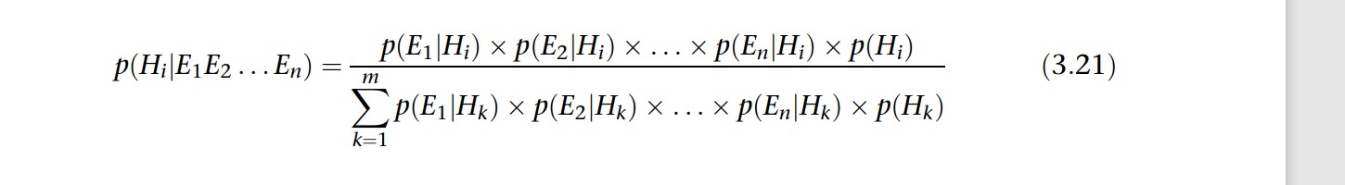

How does an expert system compute all posterior probabilities and finally rank potentially true hypotheses?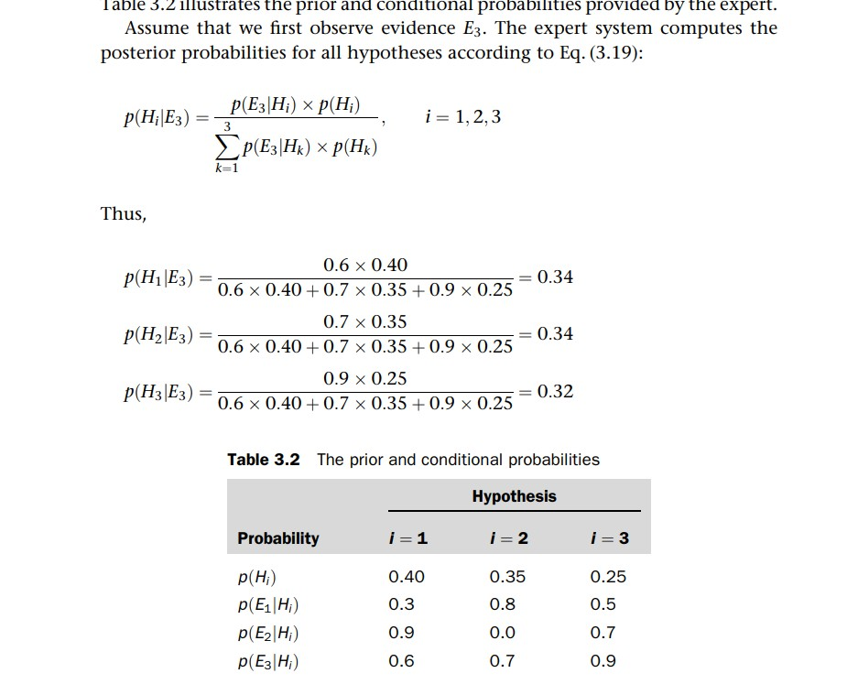

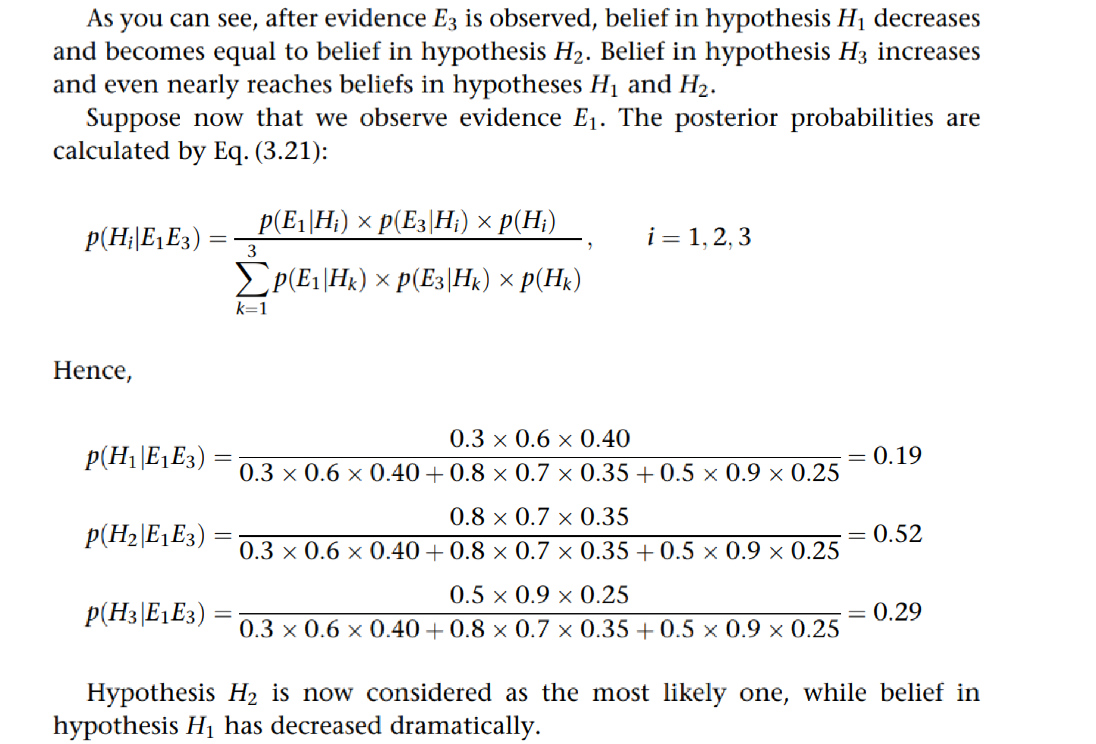

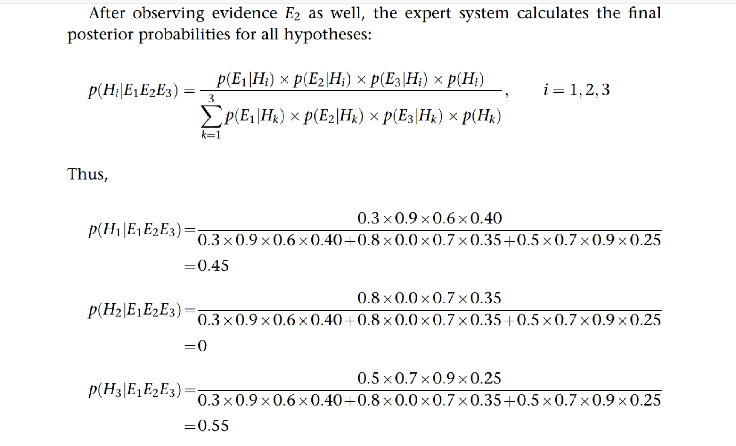

* Although the initial ranking provided by the expert was H1, H2 and H3, only hypotheses H1 and H3 remain under consideration after all evidences (E1, E2 and E3) were observed. Hypothesis H2 can now be completely abandoned. Note that hypothesis H3 is considered more likely than hypothesis H1.

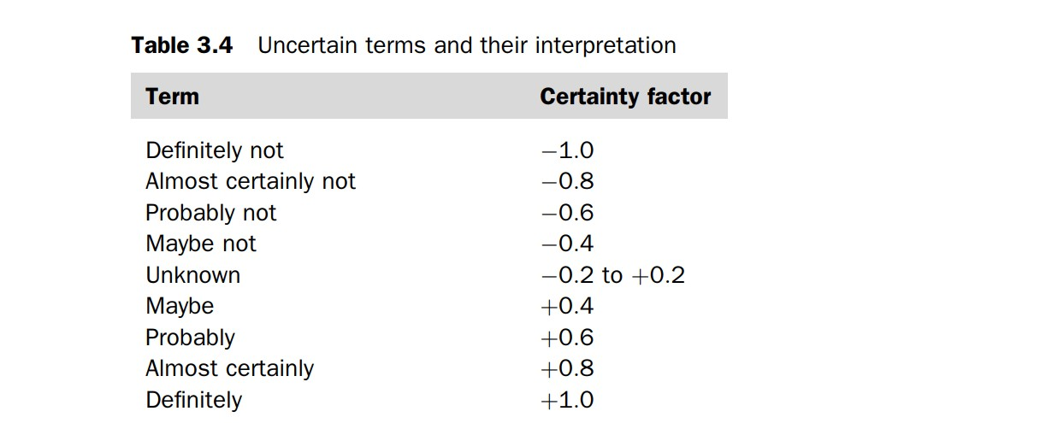

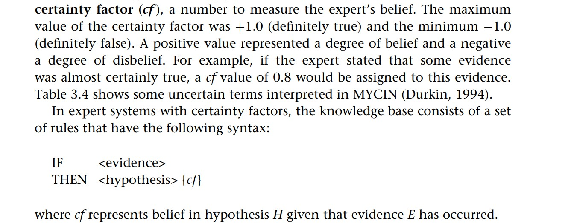

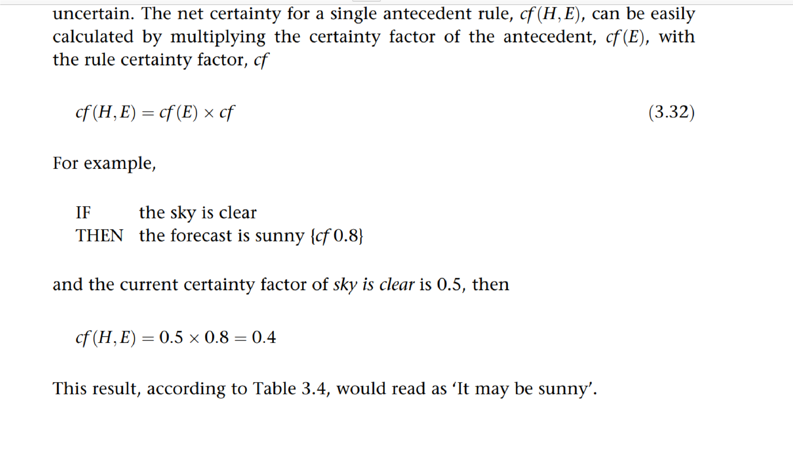

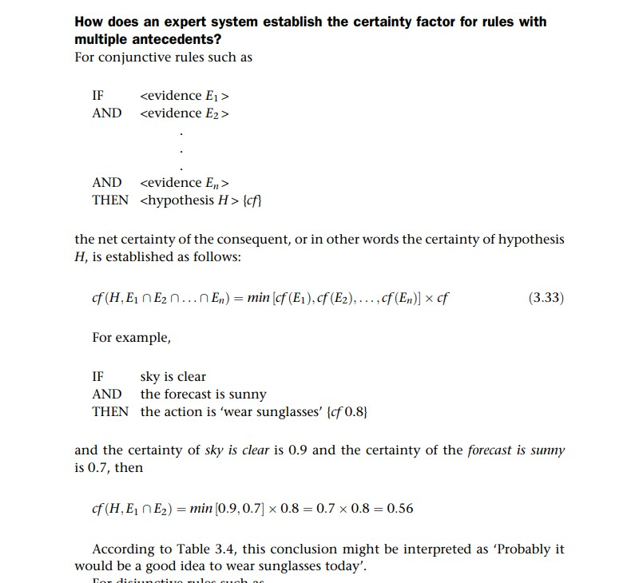

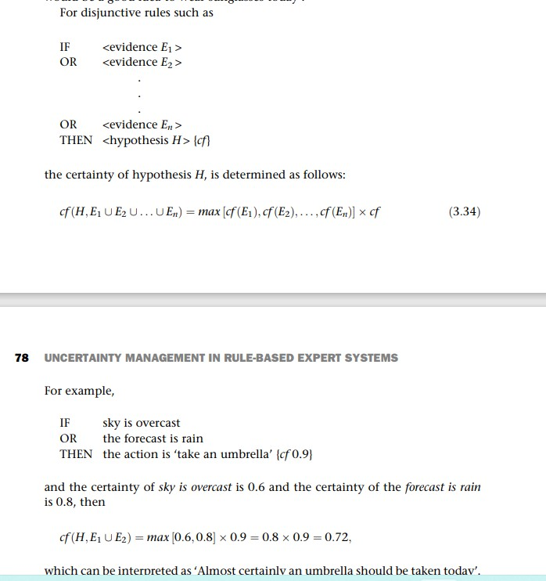

Combined Certainty Factor

* Sometimes two or even more rules can affect the same hypothesis